Khushkaranpreet kaur
IoT Assignment 02-07-2026

Q1) You are building a smart irrigation system that must monitor soil moisture,
control a water pump, and send data to a mobile application every 5 seconds. You
have both an Arduino UNO and an ESP32. Which controller would you choose
and why? Would your answer change if internet connectivity was not required?

Ans. I you should choose the ESP32 instead of the Arduino UNO.

​Why choose the ESP32?
​The project requirements dictate that you must control a water pump and send soil moisture data to a mobile application every 5 seconds. The ESP32 is the superior choice for the following reasons:
​Integrated Connectivity: The ESP32 comes with built-in Wi-Fi and Bluetooth capabilities, which are essential for sending data to a mobile application without needing additional external modules.

​Performance: It features a faster dual-core processor and significantly more memory (RAM and Flash) compared to the Arduino UNO, which is necessary to handle networking stacks and sensor data processing simultaneously.

​Power Efficiency: The ESP32 offers better power management features, including deep sleep modes, which are ideal for battery-operated remote IoT projects.

​ADC and GPIO Capabilities: It provides more advanced Analog-to-Digital Converter (ADC) channels and higher resolution than the Arduino UNO, allowing for more precise soil moisture readings.

​What if internet connectivity was not required?
​If internet connectivity were not required, the Arduino UNO could potentially be used to control the water pump and read the soil moisture sensor, provided the data is being displayed locally (e.g. on an LCD screen) or being sent via a wired connection. However, the ESP32 would still be a more robust choice due to its higher processing speed and 3.3V logic compatibility, which matches most modern sensors.

Q2) A smart factory contains 500 sensors distributed across a 2 km area. Compare
Wi-Fi, Bluetooth, LoRa, and MQTT-based communication. Which protocol or
combination of protocols would you choose and why?

ans.
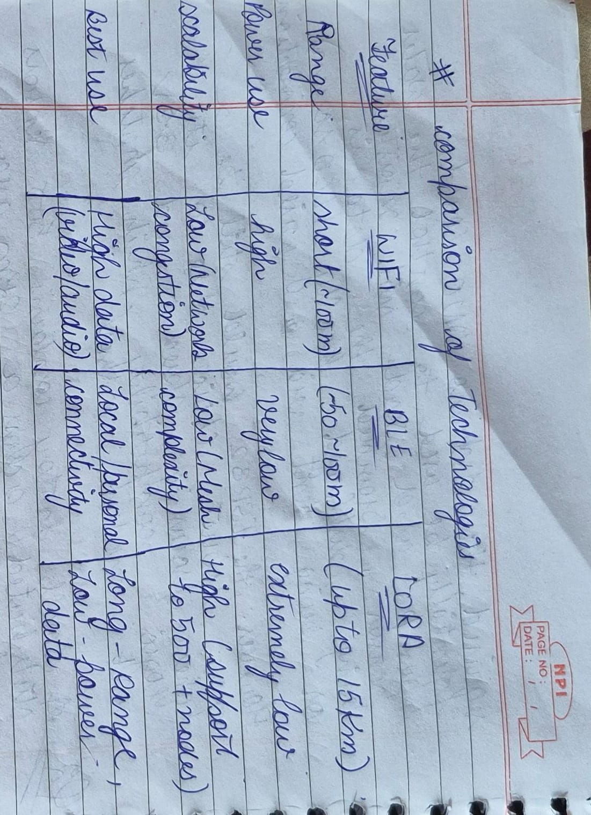
LoRa is the Correct Choice
​Massive Coverage: LoRa is specifically designed for Low Power Wide Area Networks (LPWAN). It can easily cover a 2km factory floor, even through obstacles like metal machinery and concrete walls, due to its sub-GHz frequency operation.

​High Scalability: Managing 500 sensors over Wi-Fi would require a complex and expensive network of multiple routers and repeaters, which would suffer from signal interference and connectivity drops. A LoRaWAN gateway can handle thousands of nodes simultaneously.

​Battery Longevity: Since these are likely sensors that report status periodically, LoRa's extremely low power consumption allows the nodes to run for years on a single small battery, whereas Wi-Fi would require frequent charging or constant power.

​Cost-Effective Infrastructure: Deploying a single (or a few) LoRa gateway(s) is significantly cheaper and easier than wiring a 2km area for extensive Wi-Fi coverage.

​Could a "Combination" Work?
​A combination is only useful if you need different features in one device. For instance:
​LoRa + BLE: You could use a LoRa module for the long-range data transmission to the central factory server, and incorporate BLE in the sensors to allow a technician with a smartphone to locally configure or troubleshoot a specific sensor without needing to access the long-range network.

Q3) A temperature sensor suddenly starts showing impossible values (e.g., –120°C
or 300°C). How you would determine whether the problem lies in the sensor,
wiring, power supply, ADC, or software.

Ans. To troubleshoot "impossible" sensor values, perform these checks in order:

​Software: Print the raw ADC value. If it is stable, the issue is in your math/code. If it is erratic, the issue is hardware.

​Power Supply: Use a multimeter to ensure the voltage at the sensor matches its datasheet requirements.

​Wiring: Check for loose connections or electromagnetic interference. Move wires to see if data stability changes.

​Sensor: Swap with a known-good sensor. If it works, the original sensor was faulty.

​ADC: Test the microcontroller pin by connecting it to ground (GND) or V_{CC}. If it doesn't read the correct min/max, the input pin is damaged.

Q4) An ESP32-based weather station must operate on battery power for six months
without maintenance. What hardware and software modifications would you make
to maximize battery life?

Ans. To maximize battery life for an ESP32 weather station, focus on reducing power consumption during idle periods. Here are the key modifications:
​Software Modifications

​Deep Sleep Mode: This is the most critical step. Use the esp_deep_sleep_start() function to put the ESP32 into a near-zero power state between sensor readings.

​Reduce Transmission Frequency: Wake the device only when necessary (e.g., every 15–30 minutes) to read sensors and send data, rather than staying active continuously.

​Minimize Wi-Fi Time: Wi-Fi is the biggest power drain. Use static IP addresses for faster connection times and transmit data in small, efficient packets (e.g., using MQTT).

​Disable Peripherals: In code, explicitly turn off unused components like the internal ADC, Bluetooth, and unused GPIO pins before sleeping.

​Hardware Modifications
​Remove Power LEDs and Regulators: Standard development boards have power-on LEDs and inefficient voltage regulators that consume power constantly. Use a "bare" ESP32 chip or a specialized low-power breakout board.

​Efficient Power Regulation: Use a high-efficiency LDO (Low-Dropout regulator) with a very low quiescent current (e.g., MCP1700 or HT7333).

​Sensor Selection: Choose sensors that operate at low voltages and support a "power-down" or "standby" mode.

​Power Gating: Use a MOSFET to physically cut power to external sensors when they are not in use, so they don't consume "leakage" current while the ESP32 is sleeping.

Q5) An automatic braking system in a vehicle requires communication with almost
zero delay. Which communication method would you choose and why?

Ans. For an automatic braking system, where safety is mission-critical and "almost zero delay" (real-time deterministic performance) is required, the best choice is CAN Bus (Controller Area Network).
​
because:

​Real-Time Performance: CAN is designed for low latency. It uses a prioritized message arbitration system, ensuring that high-priority messages (like a "brake" command) immediately override lower-priority traffic (like status updates) on the bus.

​High Reliability: It is built for harsh environments (like vehicles) with high electromagnetic interference. It includes robust error detection and fault confinement mechanisms, ensuring that a single faulty sensor node doesn't bring down the entire braking system.

​Deterministic: Unlike Ethernet or Wi-Fi, which can have unpredictable packet collisions and variable latency, CAN provides predictable, near-instant communication between the electronic control units (ECUs).

​Why other methods fail here:
​Wi-Fi/Bluetooth: These are high-latency and subject to interference, dropped packets, and connectivity issues. They are unsuitable for life-critical safety systems.

​Standard Serial (UART): Not designed for multi-node networks; it lacks the built-in collision detection and arbitration that makes CAN bus safe for critical vehicle systems.

Q6) You need to measure the average temperature of a classroom using only one
sensor. Where would you place the sensor and why? Explain how poor placement
could afect the accuracy of your measurements. Assume the classroom to be a
square-base cuboid of side length “a” and height “b”.

Ans. To measure the "average" temperature of a classroom using only one sensor, you should place it at approximately 1.2 to 1.5 meters (roughly 4 to 5 feet) above the floor, located in the central, open area of the room (away from walls, windows, and doors).
​Why this location?
​Avoids Localized Extremes: Placing it near a window exposes it to direct sunlight (heat) or cold drafts. Placing it near walls can lead to reading heat radiating from or trapped by the building structure.

​Representative Height: The "breathing zone" (where people actually sit/stand) is the most relevant area for comfort. Placing it too high or too low leads to readings influenced by ceiling heat stratification or floor-level coolness.

​Air Circulation: The center of the room represents the mixed air environment, providing a much more accurate average than a sensor placed near an HVAC vent or a corner.
​How poor placement affects accuracy

​Near Heat Sources: Placing it near a projector, computer, or radiator will cause the sensor to read much higher than the actual room temperature.

​Near Windows/Doors: These areas suffer from drafts and heat transfer, making the sensor highly sensitive to outside weather rather than the indoor environment.

​Blocked/Cornered: Placing it in a corner or near furniture restricts airflow, leading to "stagnant air" readings that do not represent the conditions experienced by the occupants in the rest of the room.

Q7) Under what situations could an analog sensor perform better than a digital
one?

Ans. Analog sensors are often better in the following situations:

​Near-Zero Latency: Analog sensors provide continuous, real-time signals. In high-speed control systems, this avoids the sampling delay inherent in digital sensors.

​Higher Precision/Resolution: They are not limited by "bit-depth" or quantization steps. If you need to detect extremely minute changes, an analog sensor often provides higher effective resolution.

​Lower Power & Complexity: They are ideal for simple, low-power applications where you don't want to power a microcontroller or manage digital communication protocols (I^2C, SPI).

​Direct Analog Processing: If your system uses analog circuits (like filters or amplifiers) for control, you can feed the sensor data directly into those circuits without the need for digital conversion.

Q8) Draw the complete architecture/block diagram of your IoT project, beginning
from the sensor and ending at the user interface. Identify every possible point
where a failure could occur and suggest one solution for each.

Sensor
↓
ESP32
↓
Signal Processing
↓
Wi-Fi
↓
Internet
↓
ThingSpeak Cloud
↓
Dashboard / Mobile App
↓
User
Q9) If an attacker gains access to your IoT device through the Wi-Fi network, what
kinds of attacks could they perform? Suggest at least five methods to improve the
security of the system (with applicable solutions, do not cite far-fetched ideas)

ANS:If someone gains unauthorized access to the warehouse Wi-Fi, they could steal sensor data, manipulate relay controls, inject false readings, or even disable the monitoring system. To improve security, I would use WPA2 or WPA3 encryption, strong passwords, HTTPS or TLS encryption for cloud communication, secure API keys, authentication mechanisms, and regular firmware updates. These measures significantly reduce the risk of cyberattacks.

Q10) Your ESP32 must simultaneously interface with a DHT11 sensor, an
ultrasonic sensor, an OLED display, a relay module, and a soil moisture sensor.
What hardware or software conflicts could occur, and how would you solve them?

ANS:Interfacing multiple devices with the ESP32 can lead to GPIO pin conflicts, communication timing issues, power supply limitations, and electrical noise from devices like relays. I would assign dedicated GPIO pins for each device, use non-blocking programming with millis() instead of long delays, isolate noisy components with proper protection circuits, and use a stable external power supply when necessary. These steps improve overall system reliability.

Q11) An ESP32 uploads sensor data to the cloud every minute. The internet
connection fails for 12 hours. Design a strategy that ensures no important data is
permanently lost

ANS:If the internet connection fails, the ESP32 will continue collecting sensor readings and store them in local memory such as SPIFFS, LittleFS, or an SD card. The system will periodically check whether the internet connection has been restored. Once connectivity returns, the stored readings will be uploaded to the cloud in chronological order, and the local copies will be deleted only after successful transmission. This approach ensures that no sensor data is lost during network outages.

Q12) Your IoT device must operate continuously for five years without human
intervention. What changes would you make to both the hardware and software to
improve long-term reliability?

ANS:To ensure long-term reliability, I would use industrial-grade sensors, a high-quality PCB, surge protection, and a weather-resistant enclosure to protect the hardware. On the software side, I would implement watchdog timers, automatic error recovery, memory management to prevent leaks, regular firmware updates using OTA, and proper error logging. These improvements help the system operate continuously with minimal maintenance.

Q13) Can an IoT system be considered "smart" if it does not use Artificial
Intelligence? Justify your answer with suitable examples. What differentiates
“smart” from “intelligent”?

ANS:Yes a system can be smart without being intelligent. A smart system follows predefined rules to automate tasks, such as turning on a fan when the temperature exceeds a certain limit. However, it does not learn from experience or adapt to changing conditions. An intelligent system uses artificial intelligence or machine learning to analyze data recognize patterns make predictions and improve its decisions over time. Therefore, every intelligent system is smart, but not every smart system is intelligent.

Q14) Compare polling and interrupt-based programming in embedded systems. In
which situations would interrupts significantly improve the performance of an IoT
Device?

ANS:Polling is a method where the processor repeatedly checks whether an event has occurred, which wastes processing time and consumes more power. Interrupts allow the processor to perform other tasks until an event occurs, at which point it immediately responds. Interrupts provide faster response times, better CPU utilization, and lower power consumption. Therefore, interrupts are generally preferred for applications such as emergency alarms, motion detection, button presses, and communication events.

Q15) Every engineering design involves trade-offs. Looking at your own IoT
project, identify three design decisions where you sacrificed one aspect (such as
cost, speed, power, accuracy, or complexity) to improve another. Explain whether
you believe those trade-offs were justified.

ANS:While designing the project, I balanced cost, simplicity, and performance. I selected the DHT11 sensor because it is affordable and sufficient for educational purposes, although it is less accurate than the DHT22. I used ThingSpeak because it is free, easy to integrate, and suitable for monitoring sensor data, even though it offers fewer advanced features than commercial IoT platforms. I also kept Wi-Fi continuously active to provide real-time monitoring, accepting higher power consumption in exchange for immediate cloud updates. These trade-offs allowed the project to remain simple, economical, and effective.

Q16) Create a flowchart for an IoT system that stores sensor readings locally
whenever Wi-Fi is unavailable and automatically uploads the stored data once the
connection is restored. Mention all the programs/protocols/I-O used in the system.
ANS:
Start
↓
Initialize ESP32
↓
Read Sensors
↓
Wi-Fi Connected?
↓Yes
Upload Current Data
↓
Upload Stored Data
↓
Delete Uploaded Data
↓
Wait
↓
Repeat

↓No
Store Data in Flash/SD
↓
Retry Wi-Fi
↓
Repeat

Programs/Protocols/I-O used:
ESP32 ,DHT11 library,Wi-Fi,HTTP/MQTT,ThingSpeak API,SPIFFS/SD Card,GPIO,ADC,I2C (OLED)

Q17) Draw a flowchart showing how an ESP32 performs an OTA (Over-the-Air)
firmware update, including error handling if the update fails.
ANS:
Start
↓
Connect Wi-Fi
↓
Check OTA Server
↓
New Firmware?
↓No
Continue Normal Operation
↓Yes
Download Firmware
↓
Verify Checksum
↓
Valid?
↓No
Discard Update
Log Error
Continue Old Firmware
↓Yes
Install Firmware
↓
Restart ESP32
↓
Boot Success?
↓Yes
Run New Firmware
↓No
Rollback to Previous Firmware
Log Error
Continue Operation
Error handling:
1)Verify firmware checksum.
2)Keep previous firmware for rollback.
3)Retry download if interrupted.
4)Log update failure.
5)Continue with old firmware if update fails.

